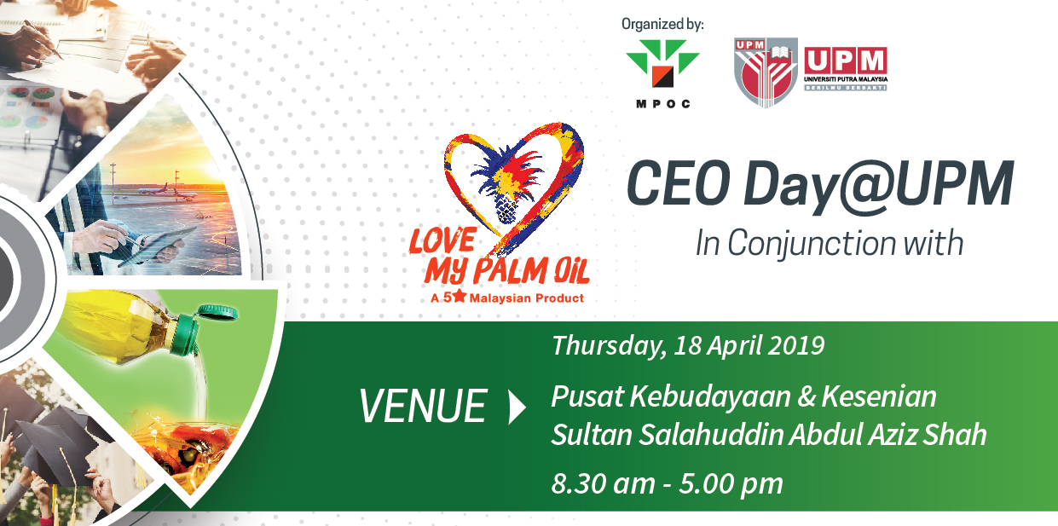
CEO Day@UPM: Love MY Palm Oil
Dewan Besar, Pusat Kebudayaan & Kesenian
Sultan Salahuddin Abdul Aziz Shah, Universiti Putra Malaysia, Serdang, Selangor

Tentative programme
Time | Programme
8.00 am | Registration  Exhibition starts
9.00 am | Arrival of guest of honour
OPENING
9.15 am | Negaraku/ Putra Gemilang/ Recite doa
9.20 am | Opening remarks by Prof. Datin Paduka Dr. Aini Ideris, Vice Chancellor, Universiti Putra Malaysia
9.35 am | Remarks by Datuk Dr. Kalyana Sundram, CEO, Malaysian Palm Oil Council
9.50 am | Launching of “Tenera Student Association, UPM”
CEO FORUM: 10.00 am-12:45 pm
Chairperson: Datuk Dr. Kalyana Sundram, CEO Malaysian Palm Oil Council

Panellists:
Mr. Joseph Tek Choon Yee
CEO & Managing Director, IJM Plantations Berhad
Fun and engaging - Does it sound like the palm oil industry?

Puan Nur Fatin Dato’ Seri Ibrahim
Group Managing Director, Dewina Holdings Sdn Bhd
Challenges and trends in food industry: Do you have what it takes to thrive in the food manufacturing sector?

Mr. Seelan Paul
CEO, Media Prima Radio Networks
Staying relevant: How to create impact in the current internet age?

Dato’ Ir. Guntur Tobeng
Group Managing Director, Gading Kencana Sdn Bhd
Challenges in turning ideas to marketable products.
12.45 pm | Lunch
1.30 pm | Morning session ends

Evening Session: 12.30 pm – 5.00 pm
Time | Programme
12.30 pm | Exhibition resumes
2.00 pm | Intervarsity Palm Oil Quiz Competition: History, science and environment
2.30 pm | Interactive activity for school student
3.00 pm | Demonstrations:  - Palm based soap making (MPOC)  - Palm based ice-cream making (FSTM UPM)
5.00 pm | Programme ends

Concurrent Sessions:
Time | Programme
9.00 am -5.00 pm | - Exhibition from companies and non-governmental organization (NGO)  - Walk-in interview  - Drop-in resume  - Luck draw  - Interactive quizzes  - Free food sampling  - Registration of Tenera Student Association, UPM

